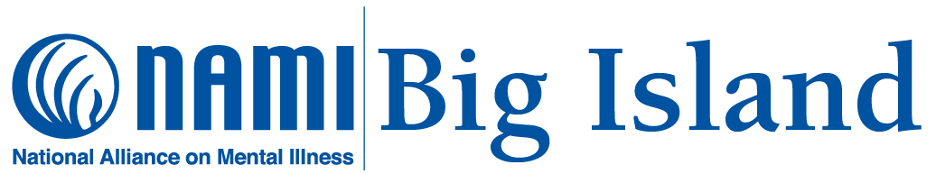

NAMI Big Island Programs and Support Groups
By NAMI Big Island Affiliate Team

Aloha from NAMI! We are NAMI Big Island, an affiliate of NAMI Hawaii. NAMI (National Alliance on Mental Illness) is the nation’s leading grassroots mental health non-profit organization. Founded in 1979, NAMI is an alliance of 600 local affiliates and 49 State Organizations with NAMI's national office headquartered in Arlington, Virginia.

NAMI envisions a world where all people affected by mental illness live healthy, fulfilling lives supported by a community that cares. Our mission is to provide education, support, advocacy, and public awareness so that all individuals and families affected by mental illness can build better lives.

Recently, NAMI Big Island partnered with Hawaii County Mayor’s Office and Hawaii Police Department to sponsor Crisis Intervention Training (CIT) sessions in Hilo and Kailua-Kona for law enforcement officers. As a result of this training, the Big Island now has thirty-nine (39) CIT certified officers who received applicable information, resources and skills towards effective problem solving and positive outcomes by police personnel responding to incidents involving mental health consumers.

NAMI Big Island offers free confidential support groups led by trained volunteers with lived experience of mental health conditions who come together, in a safe and comfortable setting, to share our struggles, promote hope and build a better tomorrow for our loved ones and for ourselves. We believe treatment works, recovery is possible, there is hope, and you are not alone!

Family Support Groups (FSG) for family caregivers are held on the last Friday of every month at 6:00-7:30 pm online via Zoom.

Connections Recovery Support Groups (CRSG), for individuals whose lives have been affected by mental illness and are living in recovery, are held the second Tuesday of every month at 6:30 pm and the third Thursday of every month at 5:30 pm, all online via Zoom. Advance registration is required to join support groups.

NAMI’s Signature Family-to-Family (F2F) is a free eight-session educational program for adult family caregivers of individuals with mental health conditions. Participants learn about mental health conditions, managing a crisis, finding services, communication, self-care, problem solving, treatment and recovery. Our next F2F Program is on Saturdays mornings, May 27-July 15 at 9:00 am-12 noon online via Zoom. Class size is limited, and advance registration is required.

Family & Friends (F&F) is another NAMI Signature Program. Similar to Family-to-Family (F2F), this free 4-hour presentation is suitable for general audiences and will be held on two Saturdays, November 4 and 11 at 10:00 am – 12 noon on zoom. Registration is required.

Register for these NAMI Hawaii programs and support groups by emailing info@namihawaii.org.

NAMIWalks Big Island is an annual event to raise awareness and funds to support the mission and activities of our affiliate. This year’s NAMIWalks is on Saturday, October 7 starting 9:00 am at Lili‘uokalani Gardens in Hilo. Everyone is invited to come on down and walk with us!

This year’s NAMI Conference held in Minneapolis, Minnesota will recognize NAMI Big Island as the NAMI Affiliate of the Year. This award acknowledges all our hard working and dedicated volunteers for their commitment to serving people in our community living with serious mental illness and the families that love them.

For more information on NAMI Big Island programs visit https://namihawaii.org, email bigisland@namihawaii.org, contact Susan McGovern at 808-238-0074 or Kathy Hammes at 808-959-2426.

This editorial is brought to you by Community First Hawaiʻi a 501 (c) 3 non-profit serving as a convener and catalyst for solutions to improve health and access to health care. For more information, please visit our website at www.communityfirsthawaii.org or Facebook and Instagram pages at @communityfirsthawaii.

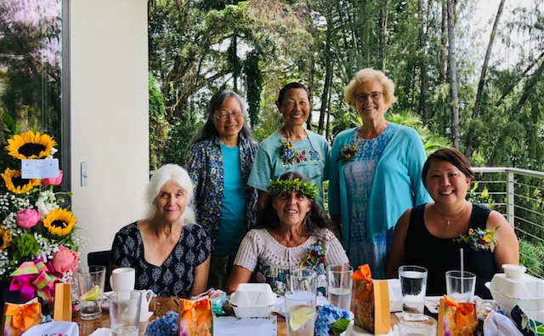
NAMI Big Island Affiliate Team (left to right) standing: Marsha Hee, Susan McGovern (Designated Affiliate Leader), Kathy Hammes; seated: Diana Sanchez, Carol Denis (NAMI Volunteer 25 Years Service Recognition) and Kumi Macdonald (NAMI Hawaii State Executive Director).

